Name:__________________________________ Date:__________________________

Un Paraíso Montessori
English Exam - Second evaluation
Teacher: Miss Esther

- Multiple Choice: Choose the correct answer

- What is a preposition?

- A word used to link nouns, pronouns, or phrases to other words within a sentence.
- A common term in reading that has a variety of meanings.
- Name of a person, place or thing.

- An Action Verb is:

- A state of being verb.
- A word naming an attribute of a noun.
- Is a verb that expresses physical or mental action. Tells us what the subject of our clause or sentence is doing-physically or mentally.

- What are the 3 types of prepositions?

- Interrogative, demonstrative, numeral
- Time, place, movement
- Time, quantitative, sequence

- The Subject-Verb Agreement rule is:

- A verb should never go with the naming part (subject) of the sentence.
- A verb should always go with the naming part (subject) of the sentence.
- A verb should sometimes go with the naming part (subject) of the sentence.

- Write S for Singular if the noun is Singular or P if the noun is Plural.

- Fox _____
- Dishes_____
- Bunnies_____
- Pitches_____
- Cities_____
- Doll______
- School_____
- Houses_____
- Toy_____
- Game_____

- Underline the verb in each sentence and write P on the line ONLY if the verb is in Past.

- Adrianna and Gabriella lived together as roommates for a long time. _____
- I run everyday in the afternoon. ______
- My neighbors speak very loud. _______
- They enjoyed the Boston marathon. _______
- You tried to fool me, but I’m too smart. ______
- My dad drives very well. ______
- My friends and I booked a flight to go to New York for this summer. ______
- Who remixed that song? ______
- Your cousin fixed the fan. ______
- We fasten our seat belts inside the car because of the speed.______

- Match the Action Verb that identifies each picture.
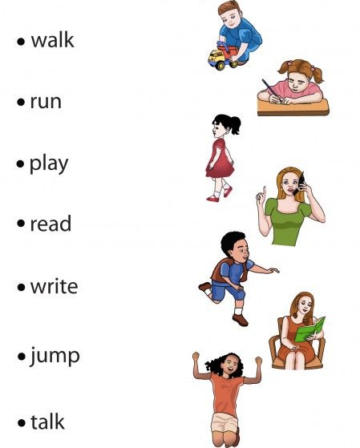

- Make a box around the Preposition in each sentence.

- He went to Germany.
- She moved here from Canada.
- This book is about dinosaurs.
- Clara went as a deer this Christmas.
- Do not go into the haunted house!
- This fabric is smooth like silk.
- They walked through the maze.
- Maria cannot live without video games.
- Do your homework before watching cartoons.
- He was pushed against the wall.

